Projects

A safety campaign educating the public about the importance of keeping
their workplaces safe for emergency responders – police officers, firefighters, and paramedics – who may have to attend the
workplace in an emergency situation. The campaign includes a short educational safety video and three 30-second public service announcements.

Creating Partnerships for Safer Workplaces

The John Petropoulos Memorial Fund is a non-profit society that raises public awareness about the importance of workplace safety for
emergency services workers. Please visit
www.jpmf.ca for details on the Fund’s safety initiatives.

Need a dynamic speaker?

Awaken

Told in the style of creative non-fiction, A Widow’s Awakening is an extraordinary story of soul mates, saints, saviours, suicide and safety in the workplace that takes the reader on an un-forgettable journey.

‘To be or not to be…a mom?’ is the question of the weekend as a group of women set sail on a houseboat.
Myths are shattered and truths revealed

pink
GAZELLE
PRODUCTIONS INC.

Synergy in Action

Pink Gazelle Productions Inc. creates literary, film and theatrical works that entertain, en- lighten and encourage people to effect positive change in themselves and the world around them. For a complete listing of projects please visit www.pinkgazelle.com.

To book Maryanne as a speaker and for speaking fees please contact:

with
Maryanne Pope

Keynote Addresses • Presentations • Half-Day Workshops

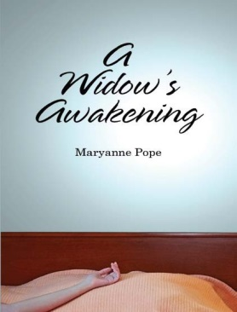
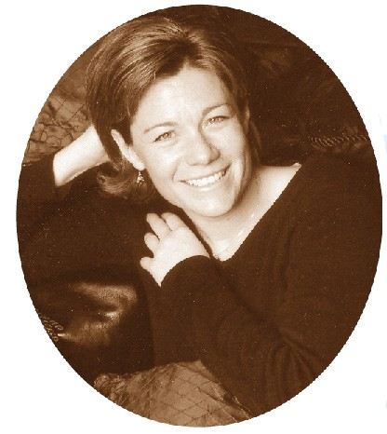
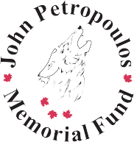
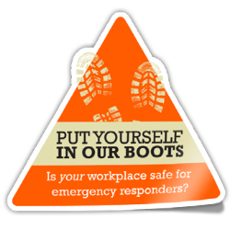
in this thought-provoking documentary that delves into the depths of motherhood. This powerful discussion-generating tool can be screened for your group.
Maryanne Pope
(250) 654-0606
maryanne@pinkgazelle.com

www.pinkgazelle.com | www.jpmf.ca
“It is my hope to encourage others to awaken to what’s
important in their own lives and the world around them…and if something needs changing – be that on an individual, societal, environmental or political level – to do it.”
– Maryanne

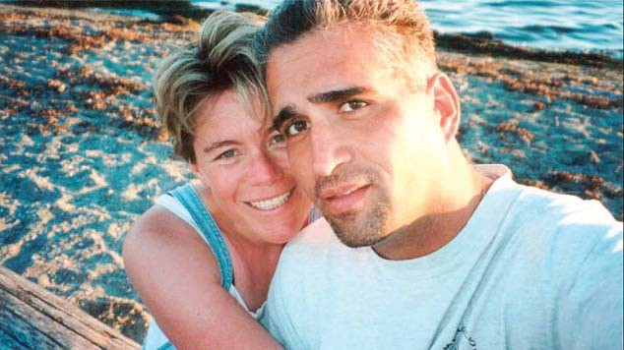
About Maryanne

Maryanne Pope is the author of A Widow’s Awakening, the upcoming book, Barrier Re- moved; a Tough Love Guide to Why, How and When to Pursue Your Dreams and the award- winning playwright of The Widows and Sav- iour.

Maryanne, a respected advocate of workplace safety, is Chair of the John Petropoulos Memo- rial Fund (JPMF), a non-profit society commit- ted to reducing preventable workplace injuries and fatalities to emergency services workers. The JPMF was set up in memory of Maryanne’s husband, Cst. John Petropoulos of the Calgary Police Service.

Experience

Maryanne speaks to diverse audiences in- cluding emergency services personnel, victim support volunteers, mental health profession- als, health and safety managers, the business community, and women’s groups. Her broad audience appeal, combined with extensive ex- perience with the media enables Maryanne to speak confidently and engage audiences of all sizes and backgrounds.

Topics

- Workplace Safety
- Overcoming Adversity
- Deconstructing Grief
- Writing Creative Non-fiction
- To Be or Not To Be . . . a Mom

Why Book Maryanne?

On September 29th, 2000, Cst John Petropou- los of the Calgary Police Service was investigat- ing a break and enter complaint at a warehouse when he stepped through a false ceiling, fell nine feet into the lunchroom below and suc- cumbed to brain injuries. There was no safety railing in place to warn him of the danger. He was 32.

So began Maryanne’s difficult journey of com- ing to terms with John’s death and her new life without him. Nine years later, she has success- fully transformed her loss into positive change through the John Petropoulos Memorial Fund’s safety initiatives as well as through her compa- ny’s creative works.

Whether she is speaking about the circum- stances that led to John’s death, her experience with grief and post-traumatic stress, workplace safety, or discussing the pros and cons of moth- erhood, Maryanne brings passion, enthusiasm, honesty, life experience, and always a touch of humour to her presentations.

Maryanne presents to a variety of groups, asso- ciation members, conference attendees, semi- nar participants, and students at the secondary and post-secondary level.

Testimonials

“Maryanne’s presentation to our volunteers was noth- ing short of remarkable. The journey she shares is insightful, heartbreaking, hopeful and even hilarious at times. Her open and honest presentation is a must
for anyone working in the field of grief and loss.” Penny Ferguson – Coordinator, Calgary Police Service Victim Services Unit

“Maryanne is an energetic speaker with an important message about facing life’s challenges head on and reaching for your dream.” Brian Willis – Winning Mind Training

“Maryanne’s passion for the subject of workplace safety is evident. She had a room full of people absolutely silent when she spoke of her experience.” Sarah King
– 2009 NAOSH Week Edmonton Committee Co-Chair

“A heartfelt and emotional tale of desperate sorrow was turned into inspiration as Maryanne used the passion
of her lost love and her eloquence to reach out and touch the hearts of hardened police veterans…not an easy feat.” Mike Turcotte – Calgary Police Veterans Associa- tion

“Hearing Maryanne’s heartfelt and touching account of John’s death really brought to light the hazards emer- gency responders face while working to protect all of us. Maryanne’s presentation was a valuable addition
to our North American Occupational Safety and Health Week Conference and Trade Show.” Michelle Roth
– 2009 NAOSH Week Calgary Committee Member

“Thank you so much for your (creative non-fiction writ- ing) workshop. Your energy, passion and sincerity was truly an inspiration for me. I gained so many insights throughout the day, I am still struggling to make sense of it all.” Cristy Hayden, workshop participant – Alexan- dra Writer’s Centre

“The students thought you were ABSOLUTELY AMAZ- ING! You were incredibly inspirational to them in so many ways. I know that your presentation touched all of us...you have such power to motivate and inspire. Thank you!” Linda MacGillvray, Teacher – Bishop Gran- din High School

